CSE – AN ALL-INCLUSIVE BUSINESS MODEL FOR GENERATIONS TO COME

O’Gorman, Bill¹; Somers, Carmel²; de Almeida Jardim, Margarida³; Klemkaite, Lina⁴; Feenan, Dave⁵; Manickam, Anu⁶

¹Centre for Enterprise Development and Regional Economy, South East Technological University, Waterford, Ireland; ²Human Capital Strategist, Technology Ireland ICT Skillnet, Dublin, Ireland; ³Centre of Entrepreneurship and International Business, Hanze University of Applied Sciences, Groningen, The Netherlands; ⁴Executive Director, Dramblys, Albacete, Spain’ ⁵Network Management, Technology Ireland ICT Skillnet, Dublin, Ireland; ⁶Centre of Entrepreneurship and International

CSE – AN ALL-INCLUSIVE BUSINESS MODEL FOR GENERATIONS TO COME

Abstract

Corporate Social Entrepreneurship (CSE) is 'a way of doing business' so that all staff in any given organisation (public, private or third sector) are fully aware of their role, responsibility and contribution to the sustainable socioeconomic enhancement of their organisations and the communities in which they live and work. Corporate Social Responsibility (CSR), on the other hand, is often understood as “a concept whereby companies integrate social and environmental concerns in their business operations and in their interaction with their stakeholders on a voluntary basis. (…) It opens a way of managing change and of reconciling social development with improved competitiveness.” (CEC, 2001, p.7). Whereas there is an overlap between CSE and CSR and a similarity of concept, they are on very different trajectories. CSE is not just another form of CSR, it is a process for invigorating and advancing the development of CSR. CSE provides an approach that will accelerate the CSR journey. The fundamental purpose is therefore to accelerate companies’ organisational transformation into a more powerful generation of societal betterment (Austin and Reficco 2009, p.2). CSE includes: creating an enabling entrepreneurial environment, fostering corporate social intrapreneurship, amplifying corporate purpose and values as well as building strategic alliances in order to solve economic and social problems and to promote the success of emerging innovative business strategies. This paper presents the journey, the pathway, the process, tools and techniques that will enable organisations to successfully progress from CSR to CSE.

Keywords: CSE, CSR, socioeconomic development, entrepreneurship, society

CSE - AN ALL-INCLUSIVE BUSINESS MODEL FOR GENERATIONS TO COME
Introduction
Corporate Social Entrepreneurship (CSE) is an emerging concept, concerning new practices. Therefore, inevitably there are still ambiguities and discussions with regards to the meaning, relevance, and application of the concept (Couto, Parente, Cruz, Castro and Alegre, 2020). CSE has emerged based on the need for businesses to become more socially aware and committed to addressing societal needs and global Sustainable Development Goals (SDG). It is an evolution and the next step from Corporate Social Responsibility (CSR) (Bowen, 1953; Azevedo and Carlos, 2015). CSE embodies characteristics of corporate entrepreneurship - as defined by Say, Schumpeter, Drucker and Stevenson, and the characteristics of social entrepreneurship.
This paper explores the concept of CSE and its need for a transition to a more social, economic, and environmental ‘way of doing business’. According to Austin and Reficco (2009), CSE is not just another form of CSR, but a process for advancing and evolving the development of CSR. To achieve this transition, it is imperative to prepare future entrepreneurs and current businesses to foster the power of entrepreneurship and businesses to address societal issues. Hence, the European Corporate Social Entrepreneurship Curriculum (ECSEC) developed by the EMBRACE project partnership is a step in the direction to equip business people and educators to navigate through these new complex, chaotic, and uncertain organisational systems. EMBRACE is a three-year initiative funded within the framework of ERASMUS+, Knowledge Alliances programme. The project aims to promote CSE in Higher Education Institutions (HEI) educational programmes to improve students’ competences, employability and attitudes contributing to the creation of new business opportunities dealing with social change inside companies as well as promoting collaboration among companies. The project’s overall objective is the establishment of a sustainable environment that facilitates the exchange, flow and co-creation of knowledge between HEIs, enterprises, organisations (public, private and third sector); resulting in the creation of new business opportunities dealing with social change addressing the SDGs both within and external to organisations (for further details see http://csembrace.eu/ and EduLab).

The Path to Corporate Social Entrepreneurship (CSE)
To best grasp the concept of Corporate Social Entrepreneurship (CSE), one needs to understand its origins and the pathway leading to CSE. The concept is considered the evolution and next stage of Corporate Social Responsibility (CSR) (Bowen, 1953; Azevedo and Carlos, 2015), building upon a series of other concepts and embodying relevant characteristics from these (see Figure 1).
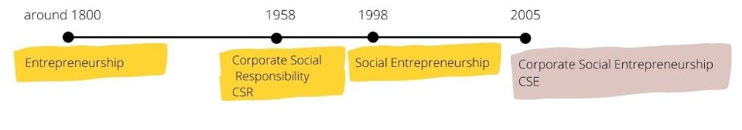
Figure 1. Timeline of broader concepts (EMBRACE, 2020)
CSE emerged from the pressing social and environmental challenges faced, posing risks to society’s well-being and existence as well as addressing the constantly changing environment of business. In addressing these challenges it is important to understand the fundamental purpose of CSE and the differences between CSE and CSR; Table 1 summarises these differences. From Table 1 it can be seen that CSE is a more embedded inclusive fundamental process (it is a “way of doing business”) that permeates throughout the whole of organisations be they public, private or third sector organisations.
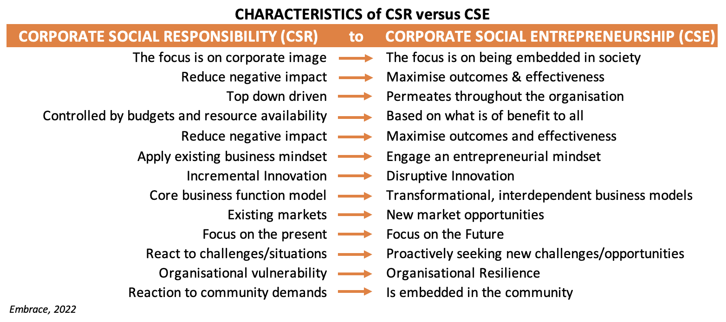
Table 1. Differences between CSR and CSE (Source: authors)
Understanding Corporate Social Responsibility (CSR)
To fully understand CSE, it is necessary first of all to have a clear understanding of its origins. CSR can be understood as being “a concept whereby companies integrate social and environmental concerns in their business operations and in their interactions with their stakeholders on a voluntary basis. It opens up a way of “managing change and of reconciling social development with improved competitiveness.” (CEC, 2001, p.7). In other words, CSR delineates the contributions organisations make to society and/or local communities. These contributions can be embedded in the core business, or on the basis of targeted activities to support society. Examples vary from sustainable or ethical (manufacturing) processes and/or products, adopting progressive human resource management practices or supporting not-for-profit initiatives.
There are several terms used to describe CSR in academic literature and on company websites, including, Social Responsibility (SR), and Corporate Citizenship (CC). This results in a range of broad working contexts for CSR, although McWilliams, Siegel, and Wright (2006) noted that regardless of the terminology used, each one of these refers to how a company goes beyond its remit so that their well-intended actions further some social good, beyond the interests of the firm itself. Essentially, CSR entails the contribution an organisation makes to their local community or to society in general.

Participating companies' CSR activities are manyfold, reflecting the diversity of CSR itself. These activities include social characteristics or features incorporated into a company’s products and manufacturing processes such as developing chemical free household cleaning products, using environmentally-friendly manufacturing technologies or recycling packaging to be reused for newly created products. CSR also includes the application of progressive human resource management practices in corporate citizenship (for example promoting employee empowerment), achieving higher levels of environmental performance (for example recycling or reducing CO2 emissions) and assisting local or global organisations to achieve their goals, particularly those in the not-for-profit sector. CSR also includes, but is not limited to, supporting social, cultural, sporting, charitable, education, and community development activities in the locality in which the ‘giving’ firm is based.

There is a consensus among a number of articles that establishing a CSR strategy can create a number of business benefits, including staff engagement and retention, improved productivity and innovation, opening up new markets and greater brand awareness and reputation. To go beyond surface-level initiatives for sustainability or corporate philanthropy, leaders in organisations need to form collaborative relationships with employees, stakeholders, clients, partners, academia, government and society to address critical societal issues of the present and the future.

The Theoretical Foundations of CSR
To understand CSR, it is helpful to be aware of the theories which underlie it as these foundational theories also impact the theoretical framework of CSE. CSR is generally categorised into four main theoretical areas: the first two Shareholder Value and Stakeholder theory stem from economic theory, the third Corporate Social Performance theory evolved from sociology, and the fourth Corporate Citizenship theory originates in political science.

Shareholder Value theory (SVT) holds that the only social responsibility of business is to increase its economic value for shareholders by making a profit. Additional social activities are acceptable only if they increase shareholder value, or if they are required by law (Friedman, 1970). Drucker (1954) claimed profitability and social responsibility can coexist, but at its core, this theory focuses on creating wealth by maximising shareholder value through focusing on the company's activities and that governmental tax systems are in place to facilitate the distribution of some of the wealth of business to society.

Stakeholder theory defines stakeholders as individuals or groups with a "stake" in the company, whether they are beneficiaries or can be adversely affected by the company. Evan and Freeman (1988) formulated stakeholder theory based on two ethical principles; the 'Principle of Corporation Rights' (P1) and the 'Principle of Corporation Effects' (P2). The former establishes that corporations should serve their customers, suppliers, owners, employees, and local communities and each of these groups should have the opportunity to participate in decisions affecting their welfare, and their rights must be protected. The latter implies that the corporation's management bears a fiduciary responsibility to stakeholders and must act in their interest as well as that of the corporation.

Corporate Social Performance theory evolved from several approaches building on theories by Sethi (1975), Carroll (1979) and Preston and Post (1981). Carroll first introduced the concept of corporate social performance outlining a set of four obligations an organisation has to society; economic, legal, ethical and philanthropic and created the ‘Pyramid of Corporate Social Responsibility ‘. This was revised by Carroll and Schwartz (2003) to three core domains; economic, legal and ethical in a Venn model framework. By integrating these three domains the model describes the organisation's efforts to meet changing societal conditions and provides a starting point to motivate and guide the activities of the business.

Corporate Citizenship theory has its roots in political science where ‘citizenship’ is at the core of the concept and reflects the participation of business in society and, as noted by Matten, Crane and Chapple (2003), business has its rightful place in society, next to other ‘citizens’ with whom the corporation forms a community. Corporate citizenship is concerned with both the ethical and social responsibilities of business as well as its role in protecting and respecting human rights. According to Gardberg and Fombrun (2006), corporate citizenship activities have a global reach, enhancing an organization's reputation, and can achieve long-term financial results since they are in fact strategic investments.

These theories can all be used to explain what companies are doing in the area of CSR. In practice, companies follow different models. According to Melé (2008), a strong normative theory is necessary with a solid philosophical foundation for it to be truly effective. It must reflect a perspective on humanity, business, and society. Therefore. it should be noted that each of the theories presented has a different philosophical foundation, as well as both positive and negative attributes. The core foundation of CSE involves aligning humanity, business and society to address and find solutions for what are often complex societal challenges.

The reason for CSE
The concept and practice of CSE is very valuable as a next step in the work of CSR and addressing the contemporary challenges. CSE is built upon the idea that a business can enhance their CSR by changing the way a company operates with a few central elements: creating an innovative and enabling environment, highlighting the corporate values and purpose, and building alliances to produce double value (Austin and Reficco, 2009; Agrawal and Sahasranamam, 2016). However, CSE is an embryonic concept which offers the potentials for making powerful forms of CSR; it is a combination of entrepreneurship and social value creation (Agrawal and Sahasranamam, 2016) which is in line with the shared value as a new approach for improving the relationship between business and society (Porter and Kramer, 2011; Michelini anf Fiorentino, 2012), it is the new, refreshed and updated version of CSR “the face of new avatar of caring capitalism in the present scenario” (Tiwari, 2015, p. 12)

The environment of businesses is faced with changes driven by geo-politics, climate and financial crises, a global pandemic, and threats to democracy and increased disinformation. These changes demand new leadership and business models which promote resilience in organisations. Moreover, the Sustainable Development Goals (SDGs) follow the Millennium Development Goals (MDGs), expanding the challenges that must be addressed to cover a wide range of interrelated topics, in the economic, social and environmental dimensions of sustainable development. For the implementation of the 2030 Agenda on the SDGs, it is urgent that organisations integrate these goals in their decision-making and that they contribute with their power of innovation for a more sustainable and inclusive future. There is a clear need for new types of interactions and commitments suitable to the ever-changing context of business and society (Uhl-Bien and Arena, 2017). CSE supports these activities by building the resilience organisations need to ‘future-proof’ themselves and become adaptive and address these SDGs.

As highlighted in the “Handbook for Corporate Social Entrepreneurs” (EMBRACE, 2021), CSE is a rather new concept which can be confused with CSR. Austin and Reficco (2009) argued that CSE is, in fact, a process that allows and enables businesses to produce more advanced forms of CSR. CSE is a subset of CSR, entailing the pursuit of initiatives with social and environmental ends while taking into account the economic responsibilities of organisations. In contrast to CSR, CSE specifically requires entrepreneurial action and innovation as driving forces, going beyond the ongoing societal engagement of organizations to entail the identification of opportunities to create future goods or services that address social or environmental challenges (EMBRACE, 2021). According to Haski-Leventhal, Glavas, and Roza (2020), CSE is a hybrid concept, mainly based on two previously developed concepts: social entrepreneurship and intrapreneurship. Due to the novelty of the concept, a common definition of CSE has not yet been agreed upon. However the EMBRACE project team, based on research conducted in 34 countries involving the analysis of 75 organisations, 41 interviews with company managers (25) and experts (16) and 220 responses to an on-line survey, define CSE as:
“A way of doing business' so that all staff in any given organisation (public, private or third sector) are fully aware of their role, responsibility and contribution to the sustainable socioeconomic enhancement of their organisations and the communities in which they live and work. The CSE process includes: creating an enabling entrepreneurial environment, fostering corporate social intrapreneurship, amplifying corporate purpose and values as well as building strategic alliances in order to solve economic and social problems and to promote the success of emerging innovative business strategies” (EMBRACE, 2021, p.10)

As today’s business landscape is increasingly influenced by the evolving pressures and preferences of consumers, regulators, and stakeholder groups, not to mention the impact of ongoing COVID-19 pandemic, CSE plays an integral role in helping firms remain competitive and find new growth opportunities. In this sense, we can argue CSE is the new CSR, a step forward for the post pandemic re-launch of local economies.

The Journey from CSR to CSE
The journey from CSR to CSE is depicted in Figure 2. The progression is achieved by shaping corporate social entrepreneurs through both education and practice. To progress from organisations with strategies reflecting CSR responsibilities (philanthropy, economic, legal, and ethical) to organisations with mission and strategies reflecting the CSE responsibilities (entrepreneurial, innovative, ecological, social, ethical, legal, and economic) in transversal and long-term activities, as depicted in Figure 2, individuals need a unique set of skills and competences. In specific terms, skills and competences that fuel an organisation with entrepreneurial endeavour and innovative value providing inspired self-sufficiency and sustainability in its community; which leads to a sustainable all-inclusive business model for generations to come.

Considering that CSE is still a relatively new concept at its preliminary stages of development, with only 2 out of 602 HEIs reviewed by the EMBRACE project team offering CSE specific courses (EMBRACE, 2020); that the concept of working as a change agent within companies to create value is increasingly more present in MBA curricula and for executives (Malinsky and McGaw, 2019); and that the Corporate Social Entrepreneur has been defined as individuals who are eager to bring social change in their respective communities, regardless of their position in the company, and carry a specific set of skills (EMBRACE, 2021), allows for the development of a multidisciplinary European Corporate Social Entrepreneurship Curriculum (ECSEC).

Specifically, the ECSEC has been developed by the EMBRACE project partnership, with the aim to increasingly include CSE as part of business education as early as undergraduate level and all levels within organisations from operatives to senior executives. The ultimate goal is to assist in the progress and implementation of embedding CSE as a norm in organisations (public, private, and third sector) context to address SDGs while at the same time supporting the generations of excess income over expenditure in the organisation.

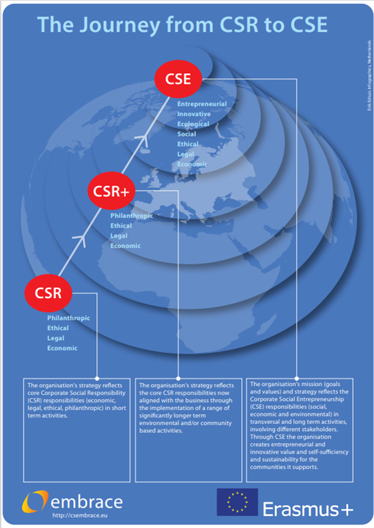
Figure 2. The journey from CSR to CSE (source: EMBRACE, 2022)
The corporate social entrepreneur
As aforementioned, the corporate social entrepreneur is an individual who is motivated to bring social change to their community, and working environment, and are valuable because they contribute with a unique set of skills complementary to the traditional business management skills (EMBRACE, 2021). The nature of CSE has been established as progression from CSR and the combination of corporate entrepreneurship and social entrepreneurship. Hence, the corporate social entrepreneur can be “characterized by a mind-set to strive for societal value creation in a persistent, learning and outreaching manner and apply the skills of entrepreneurship and communication” (Grayson, McLaren and Spitzeck. 2014). Put simply, the social corporate entrepreneur carries a combination of traits of a social entrepreneur and corporate entrepreneur, combining not only the ability of pursuing and exploring opportunities in a innovative way but also the ability to incorporate social and environmental concerns, values and impact at the core of their business (EMBRACE, 2022).
The competences of a corporate social entrepreneur were defined on the basis of the above, leading to the development of a curriculum that equips individuals with the necessary skill set and competences to pursue CSE.

Readying corporate social entrepreneurs
Four proficiency levels were identified for CSE: Novice, Intermediate, Professional and Expert; each reflecting the role of CSE the professionals will take in their organisations. The Novice corporate social entrepreneur is aware of concepts and the potential of implementing CSE in their organisation. The Intermediate corporate social entrepreneur is an individual who may not be a business professional but has an understanding of CSE and is able to identify and apply CSE strategies in practice. The Professional corporate entrepreneur is one who is immersed in business knowledge and/or practice, with specialised knowledge in CSE enabling them to identify, design and implement purposeful business propositions. Finally, the Expert corporate social entrepreneur, and the highest CSE profile, is able to design, facilitate and realise CSE strategies and mobilise others (EMBRACE, 2021). The EMBRACE project partnership has developed an online education platform (cselab.eu) offering modules and courses designed to train individuals for each CSE proficiency level, as well as a model for curriculum development, suitable at EQF levels 5 through 8.
CSE, an All-inclusive Business Model for Future Generations
Organisations which transition to CSE can build, align or merge their philanthropic business model with their core business model. True benefit comes when the organisation’s commercial and philanthropic purposes and values are strongly aligned. As noted CSE thrives when the activities the organisation undertakes are aligned with the purpose and values of the organisation. This allows everyone in the organisation to participate and for CSE to permeate throughout the organisation. CSE has entrepreneurship at its core and requires the organisation and its employees to engage a creative mindset to bring entrepreneurial and innovative solutions to bear in addressing societal challenges. This requires the organisation to look at the challenge using different lenses which may bring other requirements to the fore or require new ways of working. An example from the EMBRACE project saw the need for a data analytics platform to be designed and built for an NGO. A key requirement was that the platform would have ongoing low cost of ownership, would be easy to administer and maintain as the NGO lacked technical skills and, the platform needed to support the NGO to become a self-sustaining entity. These are not unheard of goals for a commercial technical engagements but the likelihood is that cost of ownership would be the only one of these items in the top 5 business requirements. This example provided genuine entrepreneurial and innovative challenges for the employees working on the project to overcome. In achieving the goal the skills competencies they developed can now be implemented on core business challenges. As organisations engage with social entities in CSE projects they foster new relationships with other corporate entities facilitating collaboration which can lead to new business/commercial opportunities; which in turn, can lead to new products, processes, markets and revenue streams. Therefore, engaging in CSE to develop solutions for societal benefit can result in new commercial engagements, but also solutions created for a societal benefit can be repurposed for the commercial market.

Today’s workforce is driven to find meaning and purpose in the work they do and in the organisations they work for. An article by Gartner (2022) highlighted that employees are motivated when they are appreciated and can contribute to the organisation. Employees want acknowledgment, growth opportunities and to feel valued, trusted and empowered. They are looking for a value proposition that puts them at the core of the organisation: asking employers to recognise their value and to provide value to them at a human level. This includes deeper relationships in the workplace, building a strong sense of community, and providing purpose-driven work. These key employee expectations are challenging leaders in all organisations public, private, academic and third sector to evaluate their future and purpose. At board level leaders are defining strategies to incorporate the voices of society, clients, shareholders and employees into how they evolve their workplace and the work of their organisations. Adopting CSE projects to address societal challenges has the capacity to capture the hearts and minds of employees creating purpose and meaning. The Sustainable Development Goals (SDG) are becoming more critical and organisations seek to embed solutions based on the goals in their business operations. In the same way aligning CSE with the organisation’s core purpose and values and selecting societal challenges that align well with the organisation’s core business operations will embed CSE into the organisation’s business model and create an all-inclusive business model for the organisation and for current and future generations of the workforce.

Conclusion

In conclusion, based on our research to date, we argue that Corporate Social Entrepreneurship (CSE) can build resilience in organisations to ‘future proof’ themselves against, or at least be adaptive to manage unforeseen emergencies (such as pandemics and global economic crises), creating opportunities to cultivate, nurture, and catalyze systemic change within and outside their organisations. Corporate Social Entrepreneurship has based on our research supported the development and sustainability of social organisations. This results in a more powerful form of corporate social responsibility, that of corporate social entrepreneurship which drives the creation of collaborative solutions that not only solve an immediate issue for a social enterprise, but also facilitate the sustainability of the social enterprise. This has the possibility of enabling them to continue their mission, their work in the community or society, effectively future-proofing this work for the longer term. Corporate Social Entrepreneurship is an enabler for corporate purpose. Today’s workforce are looking to find meaning in their lives and the workplace is the main focus for attaining this meaning and purpose. Corporate Social Entrepreneurship employed in an organisation, has demonstrated through our research, how the workforce engage and find purpose in designing and delivering products or solutions which have an aim of creating societal good, resolving a social issue or is focused on making a positive impact in the communities they live in. This requires collaboration which fosters deeper relationships across the workplace and in the external environment, partnering with not for profit organisations, other commercial organisations and community groups, building an enduring sense of community and generating purpose-driven work. Corporate Social Entrepreneurship has, based on a number of examples from our research, resulted in the alignment or merging of philanthropic activity with the corporate organisation’s core business model. The potential for new commercial business opportunities ensue as new relationships are formed with other commercial organisations, not for profit organisations, governmental organisations and academia through engaging in the collaborative model of corporate social entrepreneurship. What starts out as an effort to provide lasting valuable societal good can provide additional benefit for the corporate organisation as new revenue streams, new products, new markets, new relationships or partnerships are identified, when the organisation’s commercial and philanthropic purposes and values become more strongly aligned through CSE.

Employee expectations for purposeful work, and a commitment from the organisation to give back in a meaningful way to society or the community they operate in is challenging leaders in all organisations, public, private, academic and third sector to evaluate their future and purpose. This will require senior leaders in today’s organisations to define and implement strategies to incorporate the voices of society, clients, shareholders and employees as part of their strategy definition. How they will evolve the workplace and work their organisation does, to take into account the Sustainable Development Goals (SDGs) and contribute to a more sustainable and equitable society will be an ongoing leadership challenge.

Therefore, corporate social entrepreneurs, those individuals at all levels in the organisation, (leaders to junior employees), who are committed to make a difference, will need support as they embark on their CSE leadership journey, cultivating, developing, and sustaining conditions whereby these societal transformations can take place. The European Corporate Social Entrepreneurship Curriculum (ECSEC) (see http://csembrace.eu/) and the CSE EduLab (see http://csembrace.eu/) will bring them on that journey.

References
Austin, J. and Reficco, E. (2009), Corporate Social Entrepreneurship, [ebook] Boston. https://citeseerx.ist.psu.edu/viewdoc/download?doi=10.1.1.366.867&rep=rep1&type=pdf
Agrawal, A, and Sahasranamam, S. (2016), “Corporate social entrepreneurship in India”, South Asian Journal of Global Business Research, Vol 5 No. 2, pp. 214-233
Azevedo, C. & Carlos, F. (2015), Empreendedorismo Social Corporativo – Conceitos e Práticas, paper presented at the 5th Conferência Ibérica de Empreendedorismo (CIEM) 15 - 18 October 2015, Oeiras, Portugal, available at: Microsoft Word - Empreendedorismo Social Corporativo_V.CIEM_Revisto_20150924.doc (ies-sbs.org) (accessed 4 May 2022)
Bowen, H. (1953), Social Responsibilities of the Businessman, University of Iowa Press, Iowa
Carroll, A. B. (1979), “A Three‐Dimensional Conceptual Model of Corporate Performance”. Academy of Management Review, Vol.4, pp. 497–505
Carroll, A. B., and Schwartz, M. S. (2003), “Corporate Social Responsibility: A Three‐Domain Approach”. Business Ethics Quarterly, Vol. 13 No. 4, pp. 503–30.
Commission of European Communities [CEC]. (2001), Green Paper - Promoting a European Framework for Corporate Social Responsibility, available at: https://ec.europa.eu/transparency/regdoc/rep/ 1/2001/EN/1-2001-366-EN-1-0.Pdf (accessed 4 May 2022)
Couto, A. I., Parente, C., Cruz, S., Castro, F. & Alegre, T. C. (2020). “The state of Corporate Social Entrepreneurship (CSE) in Higher Education Institutions (HEIs): the Portuguese case”, paper presented at the 36th IBIMA - International Business Information Management Association IBIMA Conference, Granada, Spain, available at: The state of Corporate Social Entrepreneurship (CSE) in Higher Education Institutions (HEIs): the Portuguese case | International Business Information Management Association (IBIMA) (accessed 4 May 2022)
Drucker, P. (1954), The Practice of Management, Harper, New York, NY.
EMBRACE (2020), “Review of Corporate Social Entrepreneurship (CSE) Programmes in HEIS – Comparative Report”, available at: http://csembrace.eu/wp-content/uploads/2020/08/Review-of-CSE-in-HEIs.-Final.pdf (accessed 4 May 2022).
EMBRACE (2021), “Handbook for Corporate Social Entrepreneurs”, available at: http://csembrace.eu/wp-content/uploads/2021/06/D8-website-version_09.pdf (accessed 4 May 2022).
EMBRACE (2022), Corporate Social Entrepreneurship Curriculum, available at: http://csembrace.eu/wp-content/uploads/2022/02/EMBRACE_D9_Final_17022022.pdf (accessed 4 May 2022).
Evan, W. M., and Freeman, R. E. (1988), “A Stakeholder Theory of the Modern Corporation: Kantian Capitalism”. in T. Beauchamp and N. Bowie (Ed.), Ethical Theory and Business. Prentice Hall, Englewood Cliffs, NJ, pp. 75–93.
Friedman, M. (1970) ‘The Social Responsibility of Business is to Increase its Profits’. New York Times Magazine
Gardberg, N. A., and Fombrun, C. (2006) “Corporate Citizenship: Creating Intangible Assets across Institutional Environments”. Academy of Management Review, Vol. 31 No. 2, pp. 329–46.
Gartner (2022), “Employees seek personal value and purpose at work: Be prepared to deliver”, available at: https://www.gartner.com/en/articles/employees-seek-personal-value-and-purpose-at-work-be-prepared-to-deliver (accessed 4 May 2022).
Grayson, D., McLaren, M. and Spitzeck, H. (2014). Social Intrapreneurism and All That Jazz. How Business Innovators are Helping to Build a More Sustainable World, Routledge, New York, NY.
Haski-Leventhal, D., Glavas, A., & Roza, L, (2020), “Social intrapreneurship: A new horizon for employee engagement in CSR”, in D. Haski-Leventhal, L. Roza, & S. Brammer (Ed.), Employee engagement in corporate social responsibility. SAGE Publications, London, England, pp. 98–118.
Malinsky, E. and McGaw, N. (2019), “Unlocking the potential of Corporate Social Intrapreneurship”, The Aspen Institute, available at: Unlocking-the-Potential-of-Corporate-Social-Intrapreneurship.pdf (aspeninstitute.org) (accessed 4 May 2022).
Matten, D., Crane, A. and Chapple, W. (2003), “Behind the Mask: Revealing the True Face of Corporate Citizenship”. Journal of Business Ethics, Vol. 45 No.1–2, pp. 109–20
Porter, M.E. and Kramer, M.R. (2011), “Creating Shared Value: How to reinvent capitalism—and unleash a wave of innovation and growth”, Harvard Business Review, pp. 1-17.
McWilliams, A., Siegel, D.S. and Wright, P.M., (2006), “Corporate social responsibility: Strategic implications”, Journal of management studies, Vol. 43 No.1, pp.1-18.
Melé, D. (2008), “Corporate social responsibility theories”, in Crane, A., McWilliams, A.,
Michelini, L. and Fiorentino, D. (2012), “New business models for creating shared value”, Social Responsibility Journal, Vol. 8 No.4, pp. 561-577
Preston, L. E., and Post, J. E., (1981), “Private Management and Public Policy”, California Management Review, Vol. 23 No. 3, pp. 56–63.
Sethi, S. P. (1975), “Dimensions of Corporate Social Performance: An Analytical Framework”, California Management Review, Vol.7 No.3, pp. 58–64.
Tiwari, E. (2015), “Corporate Social Entrepreneurship: Face of caring capitalism”, SRF e-Journal of Social Science, Commerce and Management, Vol 1 No. 1, pp. 12-25, available at https://www.academia.edu/14823428/Corporate_Social_Entrepreneurship_Face_of_Caring_Capitalism (accessed 4th April 2022)
Uhl-Bien, M., & Arena, M. (2017), “Complexity leadership: Enabling people and organizations for adaptability”, Organizational Dynamics, Vol. 46 No.1, pp. 9–20.

