significance of internal and external drivers of change and weak signals – Exercise File

Drivers of Change
Identify the 10 key risks driving your organization in the next 10 years. Compare your answers to this table on global risks for the next decade.

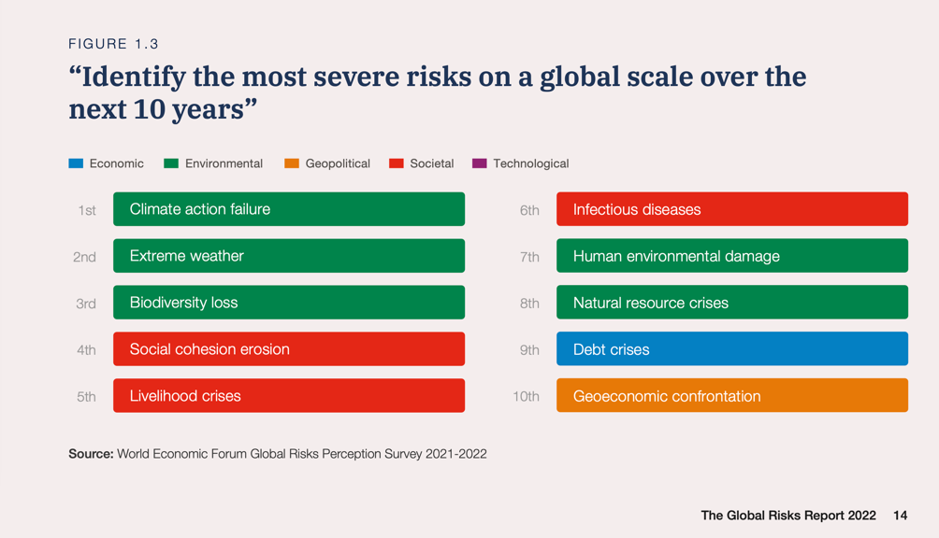

Weak Signals
Do the test: Gapminder Worldview Upgrader. What does your score tell you about your sensitivity to weak signals? Refer to Wicked World, p.59 for more insights.

